
ASSIGNMENT 3.3

Ht.No : 2303A51278

Batch – 05

Task – 01
Prompt :Create a simple Python program that asks for old and new meter readings and the customer category, applies different calculation rules for each category, and displays the total electricity usage. Write all logic directly in the main code without using functions.

Code :
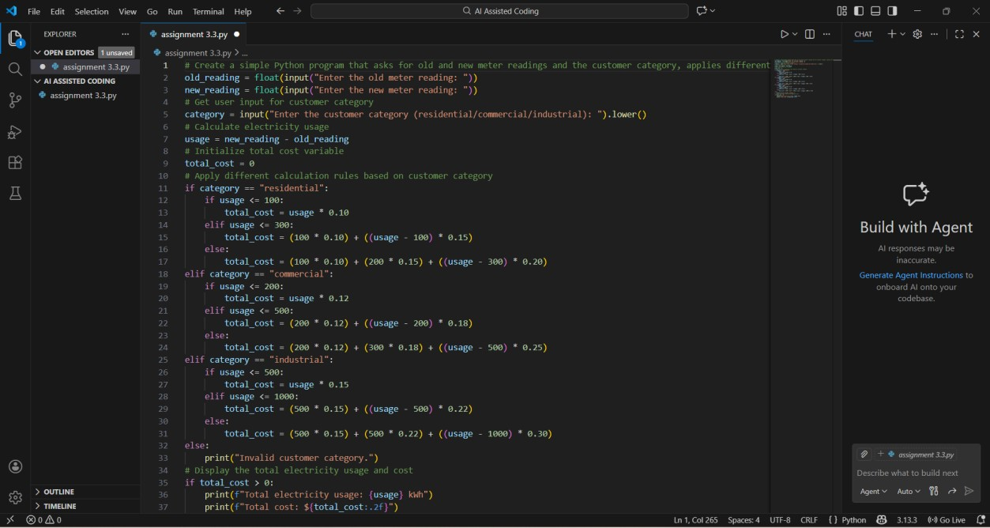

Output :

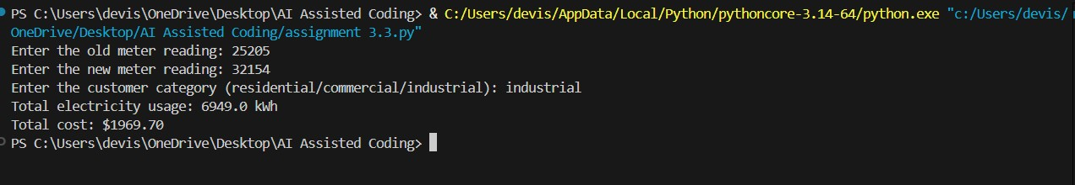

Explanation :

- Takes old and new meter readings as user input.
- Reads the customer category (residential, commercial, or industrial).
- Calculates electricity units consumed by subtracting old reading from new reading.
- Applies different billing rules based on the customer category.
- Uses slab-wise rates to calculate total cost.
- Displays total units consumed and the final electricity bill amount

TASK – 02
Prompt :Optimize the code by removing redundant calculations and improving readability.
Code :
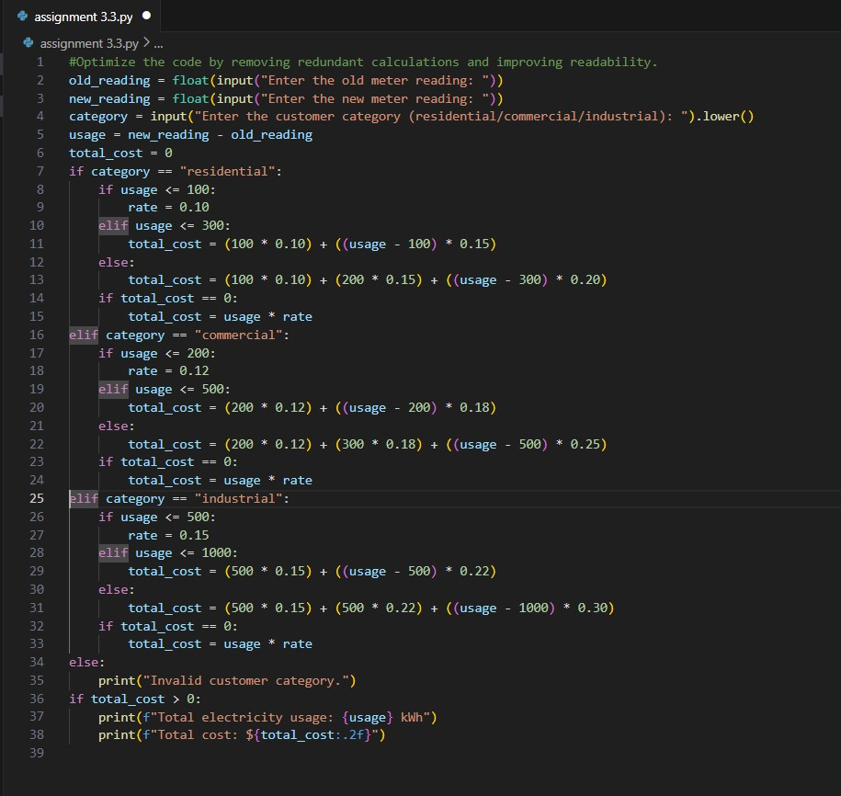

Output :

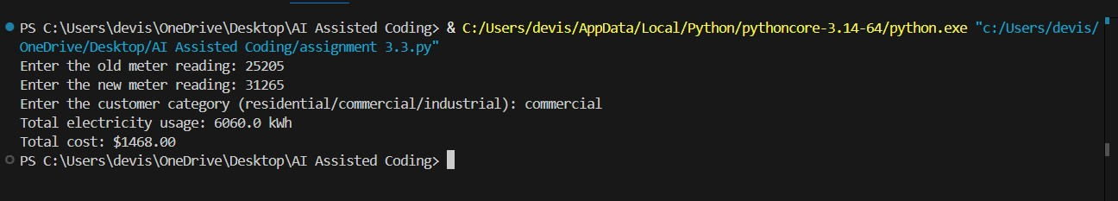

Explanation :
- Reads old and new meter readings and customer category from the user.
- Calculates units consumed by subtracting old reading from new reading.
- Uses conditional statements to apply different slab-wise rates for residential, commercial, and industrial users.
- Introduces a rate variable to avoid repeating calculations for the first slab.
- Checks if total_cost is zero and applies the first-slab rate if needed, reducing redundant computations.
- Handles invalid customer categories with a clear message.
- Displays total electricity usage and total cost in a readable format.

TASK – 03

Prompt :Generate a Python program using modular design (user-defined functions) for an electricity billing system. Uses user-defined functions to
Calculate Energy Charges, Calculate Fixed Charges. Returns calculated values. Displays the total bill amount and Energy Charges and Fixed Charges separately. Use test cases to validate the program.

Code :
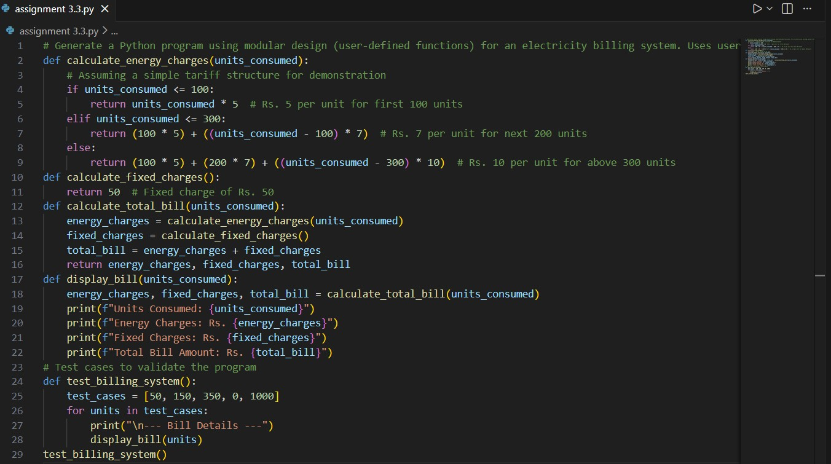

Output :
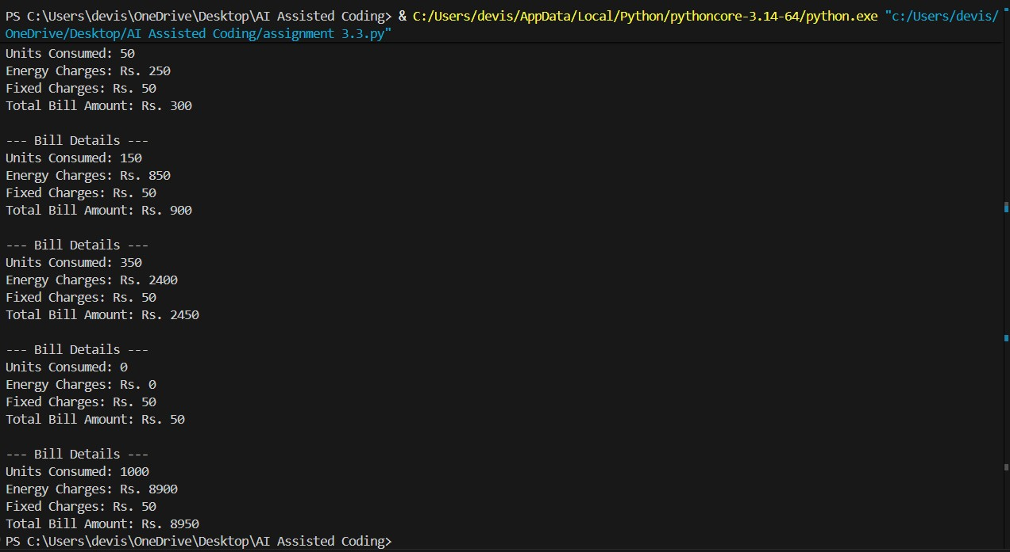
Explanation :
- The program is designed using a modular approach with user-defined functions.
- calculate_energy_charges() computes energy charges based on slab-wise tariff rates.
- calculate_fixed_charges() returns a constant fixed charge.
- calculate_total_bill() calculates the total bill by adding energy charges and fixed charges.
- display_bill() prints units consumed, energy charges, fixed charges, and total bill separately.
- test_billing_system() uses multiple test cases to validate the correctness of the program.
- This modular design improves readability, reusability, and easy testing of the program.

TASK – 04

Prompt :Enhance the electricity billing program to include Fixed Charges (FC), Customer Charges (CC), and Electricity Duty (ED). Calculate ED as a percentage of Energy Charges (EC). Print individual values of EC, FC, CC, and ED, verifyintermediate calculations, and display a clearly formatted final electricity bill showing the total payable amount.

Code :
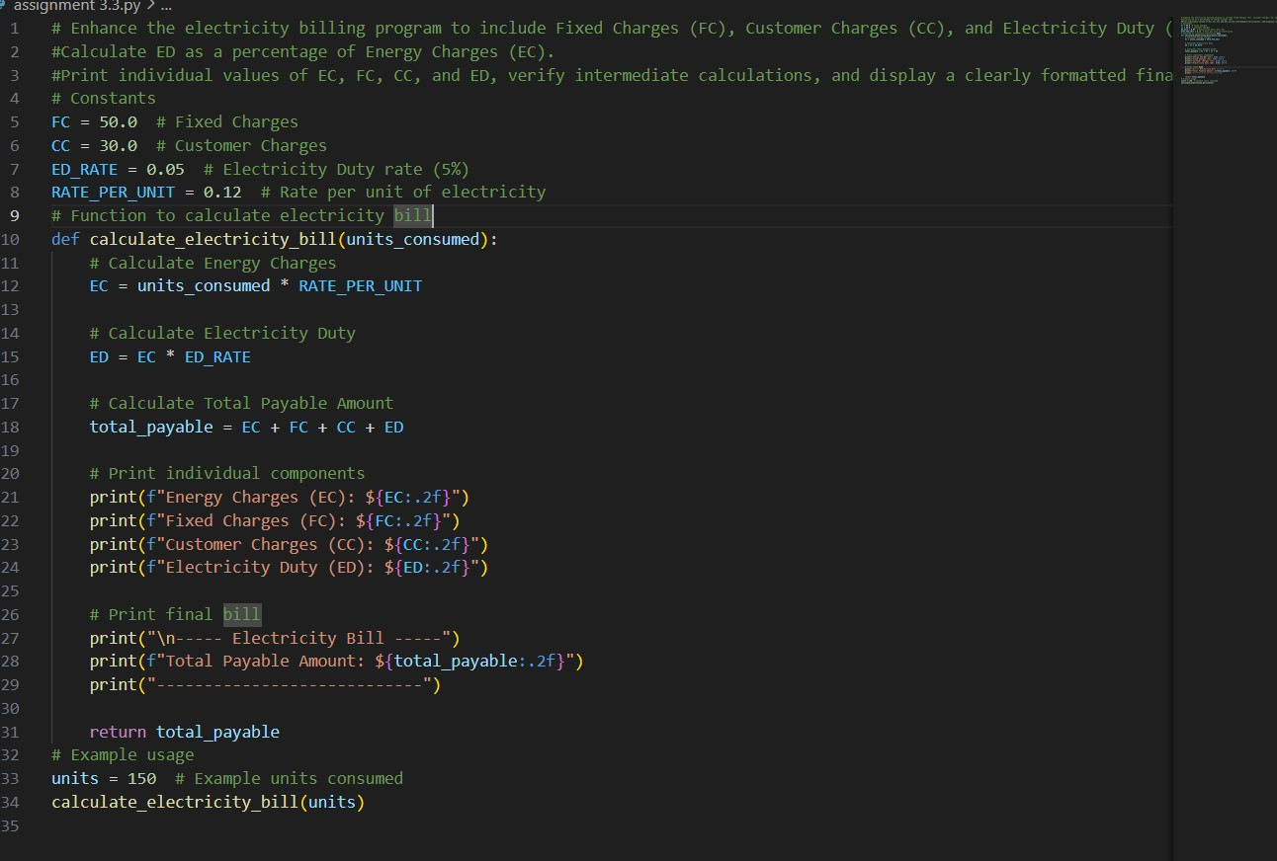

Output :
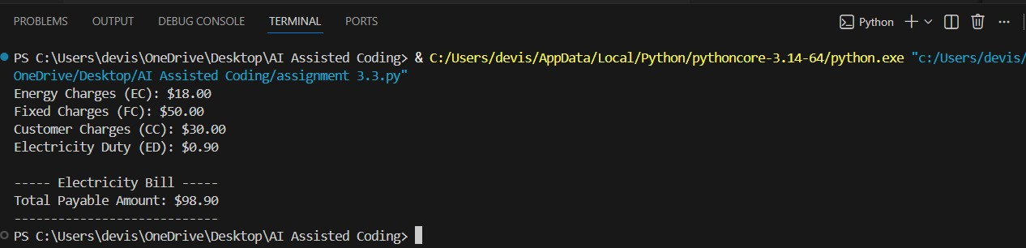

Explanation :
- The program calculates the electricity bill based on units consumed.
- Energy Charges (EC) are computed by multiplying units consumed with the rate per unit.
- Fixed Charges (FC) and Customer Charges (CC) are constant values added to the bill.
- Electricity Duty (ED) is calculated as a fixed percentage (5%) of the energy charges.
- All individual charges (EC, FC, CC, ED) are printed separately for verification.
- The total payable amount is obtained by adding EC, FC, CC, and ED.
- The final bill is displayed in a clear and structured format.

TASK – 05
Prompt :Develop a Python program to calculate an electricity bill. Compute
Energy Charges (EC) based on units consumed, add Fixed Charges (FC) and
Customer Charges (CC), and calculate Electricity Duty (ED) as a percentage of
EC. Calculate the Total Bill using the formula: Total Bill = EC + FC + CC +
ED. Display Energy Charges (EC), Fixed Charges (FC), Customer Charges (CC), Electricity Duty (ED), and the final Total Bill Amount in a clear and wellformatted output.

Code :
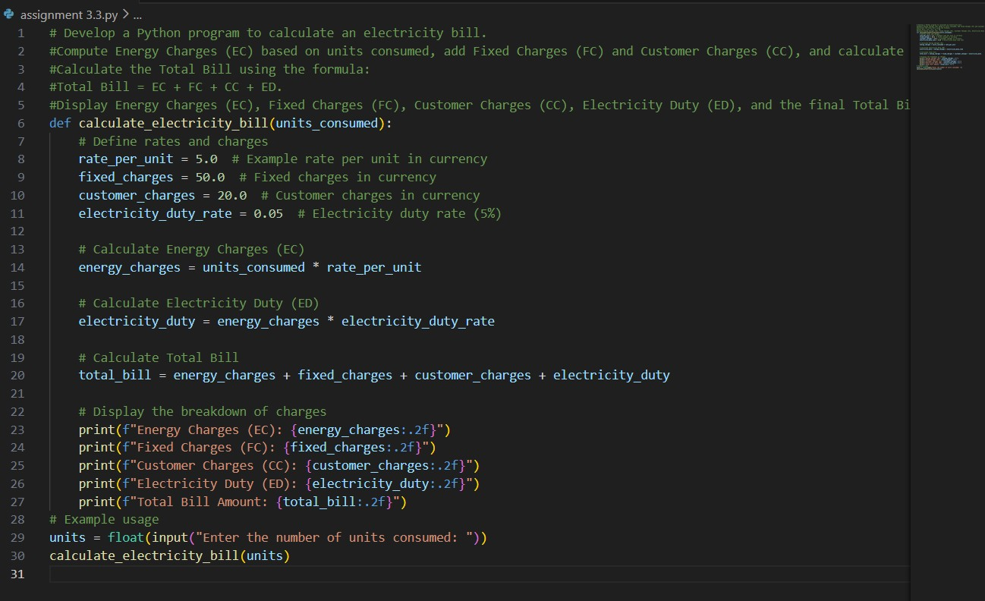

Output :

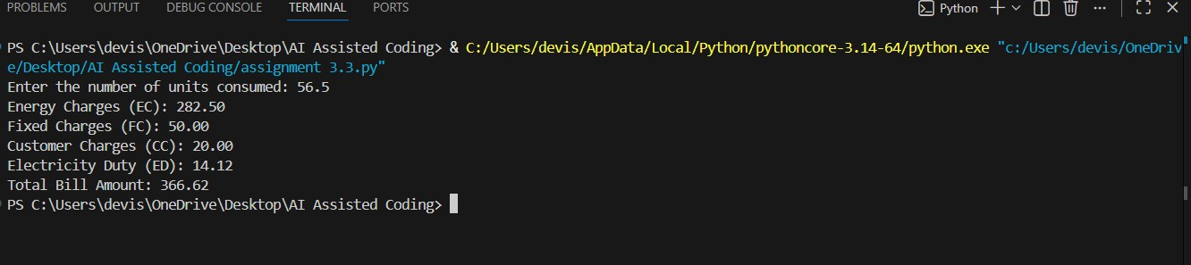

Explanation :
- The program calculates the electricity bill based on the number of units consumed.
- A function calculate_electricity_bill() is used to perform all calculations.
- Rate per unit, Fixed Charges (FC), Customer Charges (CC), and Electricity Duty rate are defined inside the function.
- Energy Charges (EC) are calculated by multiplying units consumed with the rate per unit.
- Electricity Duty (ED) is calculated as 5% of the Energy Charges.
- The Total Bill Amount is calculated using the formula:Total Bill = EC + FC + CC + ED.
- All individual charges (EC, FC, CC, ED) are printed clearly.
- Finally, the total payable amount is displayed in a well-formatted manner.

